**SMC-WEBSITE SCREENSHOTS**

**Task 1** –

Login.html -

<!DOCTYPE html>

<html lang="en">

<head>

    <meta charset="UTF-8">

    <meta name="viewport" content="width=device-width, initial-scale=1.0">

    <title>Login - SMC</title>

    <link rel="stylesheet" href="css/styles.css">

</head>

<body>

    <header>

        <h1>Welcome Back</h1>

    </header>

    <section class="narrow-section styled-tips">

        <h2>Login to Your Account</h2>

        <form action="php/login.php" method="POST">

            <label for="email">Email Address</label>

            <input type="email" id="email" name="email" required>

            <label for="password">Password</label>

            <input type="password" id="password" name="password" required>

            <input type="submit" value="Login" class="submit-button">

        </form>

        <p>Don't have an account? <a href="register.html">Register here</a></p>

    </section>

    <!-- Footer -->

    <footer>

        <p>You are here: Login</p>

        <p>&copy; 2024 SMC Ltd. | <a href="https://facebook.com">Facebook</a> | <a href="https://www.instagram.com/">Instagram</a></p>

    </footer>

</body>

</html>

Login page Screenshot-   
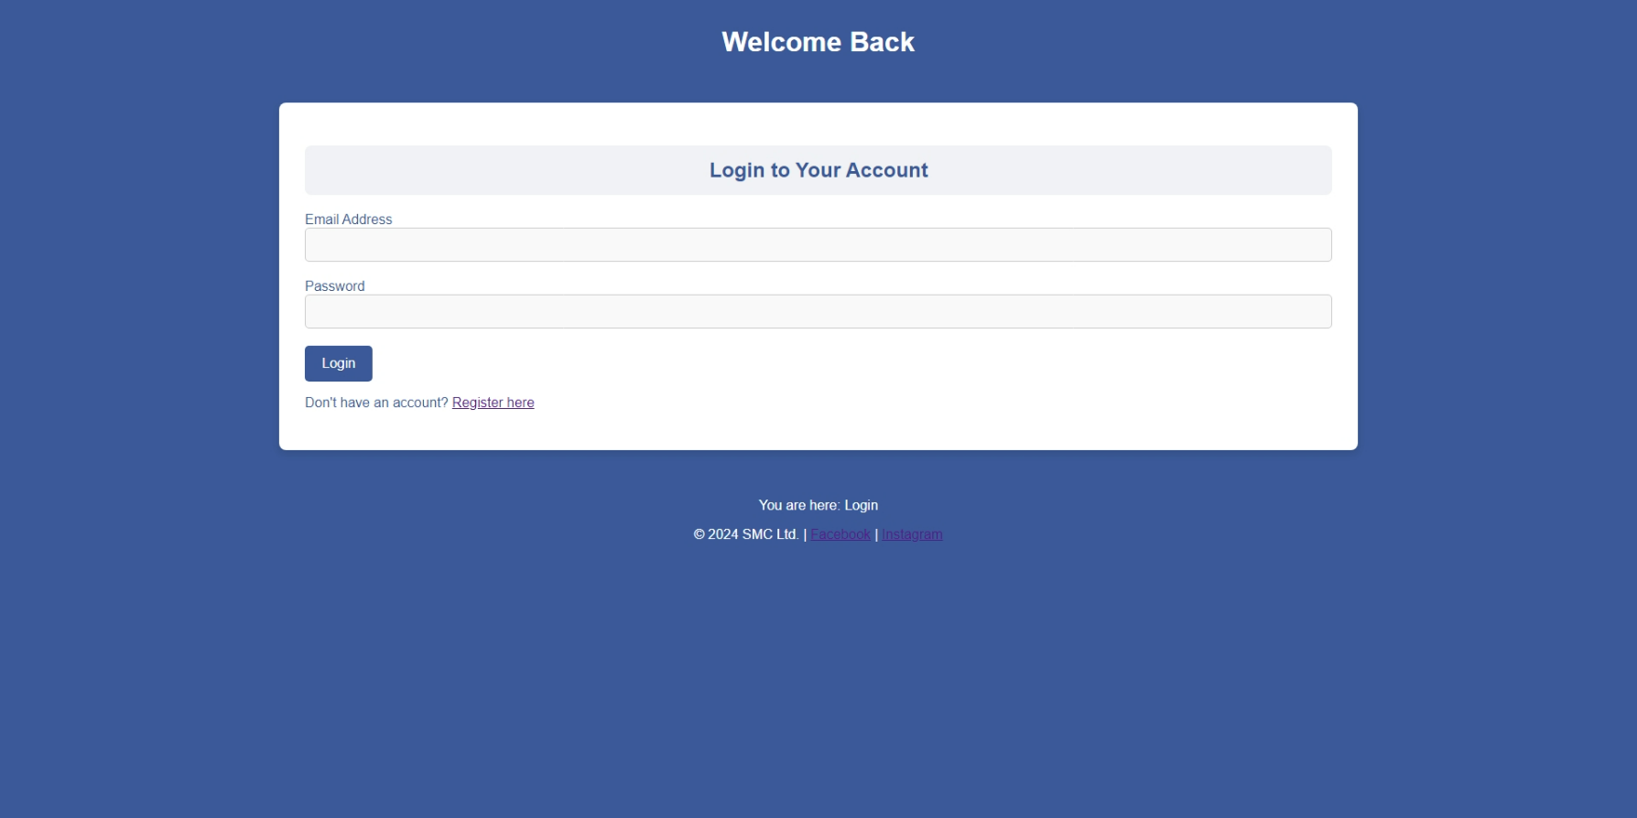

Register.html –

<!DOCTYPE html>

<html lang="en">

<head>

    <meta charset="UTF-8">

    <meta name="viewport" content="width=device-width, initial-scale=1.0">

    <title>Register - SMC</title>

    <link rel="stylesheet" href="css/styles.css">

</head>

<body>

    <header>

        <h1>Create an Account</h1>

    </header>

    <section class="narrow-section styled-tips">

        <h2>Register Now</h2>

        <form action="php/register.php" method="POST">

            <label for="first_name">First Name</label>

            <input type="text" id="first_name" name="first_name" required>

            <label for="surname">Surname</label>

            <input type="text" id="surname" name="surname" required>

            <label for="email">Email Address</label>

            <input type="email" id="email" name="email" required>

            <label for="password">Password</label>

            <input type="password" id="password" name="password" required>

            <input type="submit" value="Register" class="submit-button">

        </form>

        <p>Already have an account? <a href="login.html">Login here</a></p>

    </section>

    <!-- Footer -->

    <footer>

        <p>You are here: Register</p>

        <p>&copy; 2024 SMC Ltd. | <a href="https://facebook.com">Facebook</a> | <a href="https://www.instagram.com/">Instagram</a></p>

    </footer>

</body>

</html>

Registration page Screenshot -

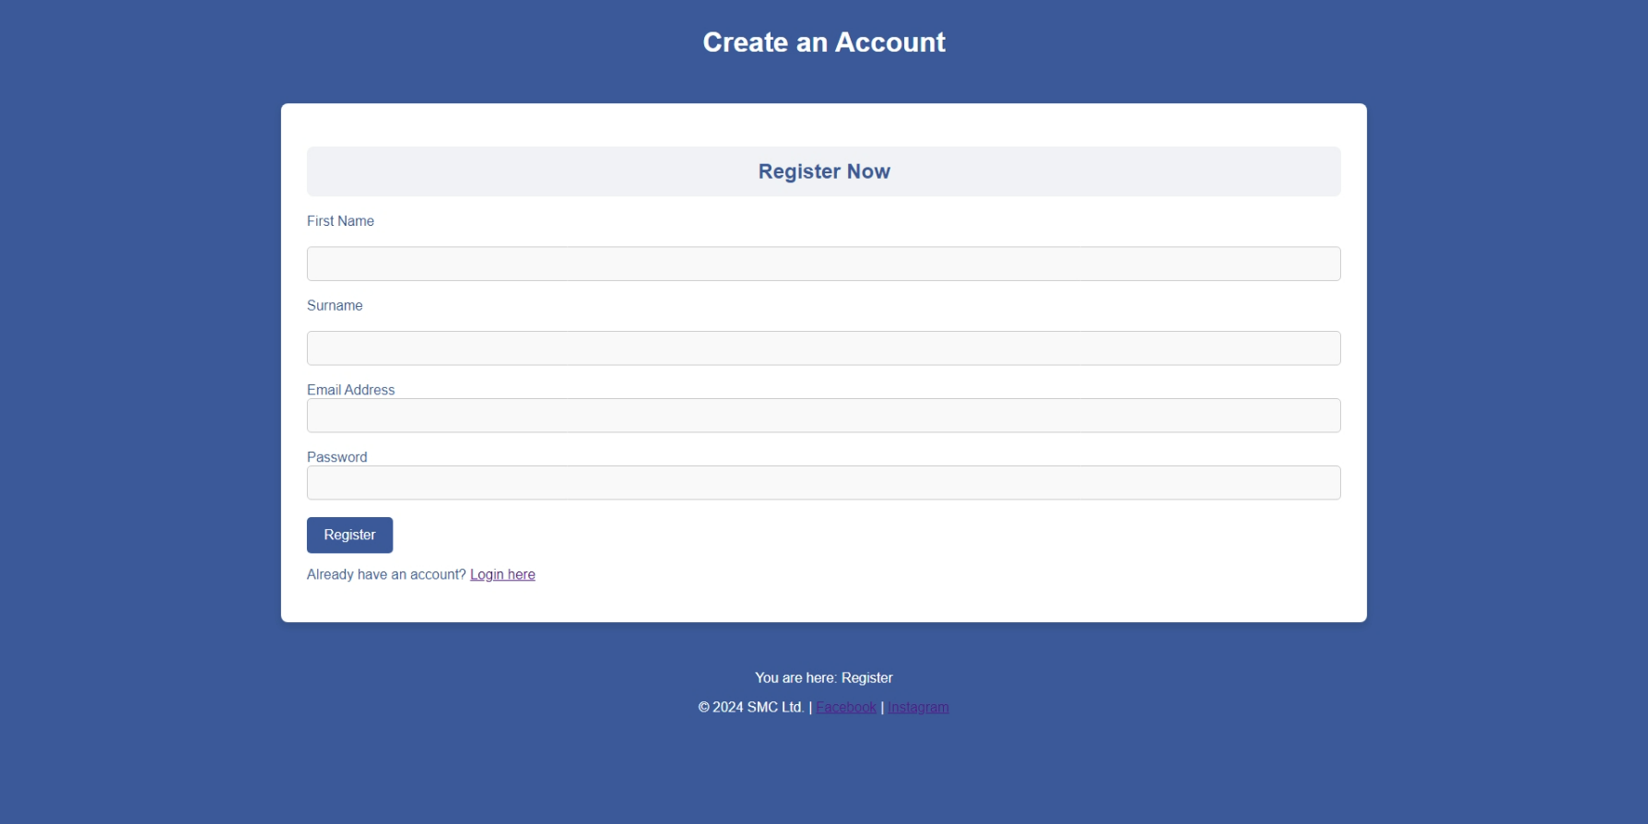

home.html

<!DOCTYPE html>

<html lang="en">

<head>

    <meta charset="UTF-8">

    <meta name="viewport" content="width=device-width, initial-scale=1.0">

    <title>SMC - Home</title>

    <link rel="stylesheet" href="css/styles.css">

    <script src="js/home.js" defer></script>

    <script src="js/toggle.js" defer></script>

</head>

<body>

    <header>

        <nav>

            <div class="hamburger" onclick="toggleMenu()">

                <div class="bar"></div>

                <div class="bar"></div>

                <div class="bar"></div>

            </div>

            <ul id="nav-links">

                <li><a href="home.html" class="active">Home</a></li>

                <li><a href="apps.html">Most Popular Apps</a></li>

                <li><a href="parents.html">How Parents Can Help</a></li>

                <li><a href="livestreaming.html">Livestreaming</a></li>

                <li class="dropdown">

                    <a href="javascript:void(0)" class="dropbtn">Information & Legislation</a>

                    <div class="dropdown-content">

                        <a href="information.html">Information</a>

                        <a href="legislation.html">Legislation</a>

                    </div>

                </li>

                <li><a href="contact.html">Contact</a></li>

                <li><a href="php/logout.php">Logout</a></li>

            </ul>

        </nav>

    </header>

    <section class="hero-section">

        <div class="hero-content">

            <h1>Welcome to Social Media Campaigns</h1>

            <p>Support Teenagers to Stay Safe Online</p>

        </div>

    </section>

    <!-- Search Bar -->

    <section id="search">

        <h2>Search Our Webpages</h2>

        <input type="text" id="searchBar" placeholder="Search..." onkeyup="searchFunction()">

        <div id="searchResults" class="dropdown-content"></div>

    </section>

    <!-- Today's Information Section -->

    <section id="web-services" class="info-cards">

        <div class="info-card">

            <h3>Current Air Quality</h3>

            <ul id="weatherData" class="air-quality-list">

                <!-- Dynamic data will be loaded here -->

            </ul>

        </div>

        <div class="info-card">

            <h3>Daily Fact</h3>

            <p id="quoteData">Loading fact...</p>

        </div>

    </section>

    <!-- Combined Social Media Apps and 3D Illustrations -->

    <section id="popular-apps-illustrations">

        <h2 class="section-heading">Most Popular Social Media Apps</h2> <!-- Added Heading -->

        <div class="social-media-cards">

            <div class="social-media-card">

                <iframe title="Facebook" frameborder="0" allowfullscreen mozallowfullscreen="true" webkitallowfullscreen="true" allow="autoplay; fullscreen; xr-spatial-tracking" execution-while-out-of-viewport execution-while-not-rendered web-share src="https://sketchfab.com/models/3f200f047cbb4266b8d178145ded1dca/embed?autostart=1&dnt=1"></iframe>

                <h3>Facebook</h3>

            </div>

            <div class="social-media-card">

                <iframe title="Instagram" frameborder="0" allowfullscreen mozallowfullscreen="true" webkitallowfullscreen="true" allow="autoplay; fullscreen; xr-spatial-tracking" execution-while-out-of-viewport execution-while-not-rendered web-share src="https://sketchfab.com/models/3294ce064aea4030a560929e57232636/embed?autostart=1&dnt=1"></iframe>

                <h3>Instagram</h3>

            </div>

            <div class="social-media-card">

                <iframe title="Twitter" frameborder="0" allowfullscreen mozallowfullscreen="true" webkitallowfullscreen="true" allow="autoplay; fullscreen; xr-spatial-tracking" execution-while-out-of-viewport execution-while-not-rendered web-share src="https://sketchfab.com/models/efd14ad1d1894af2b6701b31f82dc470/embed?autostart=1&dnt=1"></iframe>

                <h3>Whatsapp</h3>

            </div>

            <div class="social-media-card">

                <iframe title="Snapchat" frameborder="0" allowfullscreen mozallowfullscreen="true" webkitallowfullscreen="true" allow="autoplay; fullscreen; xr-spatial-tracking" execution-while-out-of-viewport execution-while-not-rendered web-share src="https://sketchfab.com/models/58840c54a37f46f9a5279ed41b6fa6b6/embed?autostart=1&dnt=1"></iframe>

                <h3>Snapchat</h3>

            </div>

        </div>

    </section>

    <!-- How to Stay Safe Online -->

    <section id="safety-tips" class="styled-tips">

        <h2>How to Stay Safe Online</h2>

        <div>

            <p>Guidelines to ensure your safety on social media:</p>

            <ul>

                <li>Use 2-factor verification passwords</li>

                <li>Be aware of fake accounts</li>

                <li>Be aware of suspicious looking links or websites</li>

                <li>Do not use passwords which are easy to guess</li>

                <li>Know what your digital footprint says</li>

            </ul>

        </div>

    </section>

    <!-- Footer -->

    <footer>

        <p>You are here: Home</p>

        <p>&copy; 2024 SMC Ltd. | <a href="https://facebook.com">Facebook</a> | <a href="https://www.instagram.com/">Instagram</a></p>

    </footer>

</body>

</html>

toggle.js –

function toggleMenu() {

    const navLinks = document.getElementById('nav-links');

    navLinks.classList.toggle('show');

}

document.addEventListener('DOMContentLoaded', function () {

    const dropdowns = document.querySelectorAll('.dropbtn');

    dropdowns.forEach(dropbtn => {

        dropbtn.addEventListener('click', function (event) {

            event.preventDefault();

            const dropdownContent = this.nextElementSibling;

            dropdownContent.style.display = dropdownContent.style.display === 'block' ? 'none' : 'block';

        });

    });

    // Close the dropdown if the user clicks outside of it

    window.onclick = function(event) {

        if (!event.target.matches('.dropbtn')) {

            const dropdownContents = document.querySelectorAll('.dropdown-content');

            dropdownContents.forEach(content => {

                if (content.style.display === 'block') {

                    content.style.display = 'none';

                }

            });

        }

    }

});

home.js

// Fetch Air Quality Data

async function fetchAirQuality() {

    const apiKey = '/RadM/mLFGB7/cc85mj+oQ==pMfQPHvH2qTPqHUg';

    const city = 'Qatar';

    try {

        const response = await fetch(`https://api.api-ninjas.com/v1/airquality?city=${city}`, {

            headers: { 'X-Api-Key': apiKey }

        });

        if (!response.ok) {

            throw new Error(`HTTP error! status: ${response.status}`);

        }

        const data = await response.json();

        console.log(data); // Log the response to understand its structure

        // Clear any existing content

        const weatherDataElement = document.getElementById('weatherData');

        weatherDataElement.innerHTML = ''; // Clear previous content

        // Display air quality data in a more organized format

        const airQualityInfo = [

            `Overall AQI: ${data.overall_aqi}`,

            `PM2.5: ${data["PM2.5"].concentration} µg/m³ (AQI: ${data["PM2.5"].aqi})`,

            `PM10: ${data["PM10"].concentration} µg/m³ (AQI: ${data["PM10"].aqi})`,

            `O3: ${data.O3.concentration} µg/m³ (AQI: ${data.O3.aqi})`

        ];

        // Create list items for each piece of information

        airQualityInfo.forEach(info => {

            const li = document.createElement('li');

            li.textContent = info;

            weatherDataElement.appendChild(li);

        });

    } catch (error) {

        document.getElementById('weatherData').innerHTML = '<li>Failed to load air quality data.</li>';

        console.error('Error fetching air quality:', error);

    }

}

// Fetch Daily Fact

async function fetchDailyFact() {

    const apiKey = '/RadM/mLFGB7/cc85mj+oQ==pMfQPHvH2qTPqHUg';

    try {

        const response = await fetch('https://api.api-ninjas.com/v1/facts', {

            headers: { 'X-Api-Key': apiKey }

        });

        if (!response.ok) {

            throw new Error(`HTTP error! status: ${response.status}`);

        }

        const data = await response.json();

        // Display the first fact from the response

        document.getElementById('quoteData').textContent = data[0].fact;

    } catch (error) {

        document.getElementById('quoteData').textContent = 'Failed to load fact.';

        console.error('Error fetching fact:', error);

    }

}

// Call the functions to fetch and display data

fetchAirQuality();

fetchDailyFact();

// List of available pages with their titles

const pages = [

    { title: "Home", url: "home.html" },

    { title: "Campaign Info", url: "information.html" },

    { title: "Most Popular Apps", url: "apps.html" },

    { title: "How Parents Can Help", url: "parents.html" },

    { title: "Livestreaming", url: "livestreaming.html" },

    { title: "Contact", url: "contact.html" },

    { title: "Legislation", url: "legislation.html" }

];

// Search function

function searchFunction() {

    const input = document.getElementById("searchBar").value.toLowerCase();

    const resultsDiv = document.getElementById("searchResults");

    // Clear previous results

    resultsDiv.innerHTML = '';

    if (input) {

        // Filter pages based on the input

        const filteredPages = pages.filter(page => page.title.toLowerCase().includes(input));

        // If there are matches, show the results

        if (filteredPages.length > 0) {

            resultsDiv.style.display = 'block';

            filteredPages.forEach(page => {

                const resultItem = document.createElement('div');

                resultItem.textContent = page.title;

                resultItem.className = 'search-result-item';

                resultItem.onclick = () => {

                    window.location.href = page.url;

                };

                resultsDiv.appendChild(resultItem);

            });

        } else {

            resultsDiv.style.display = 'none';

        }

    } else {

        resultsDiv.style.display = 'none';

    }

}

Home page Screenshot -

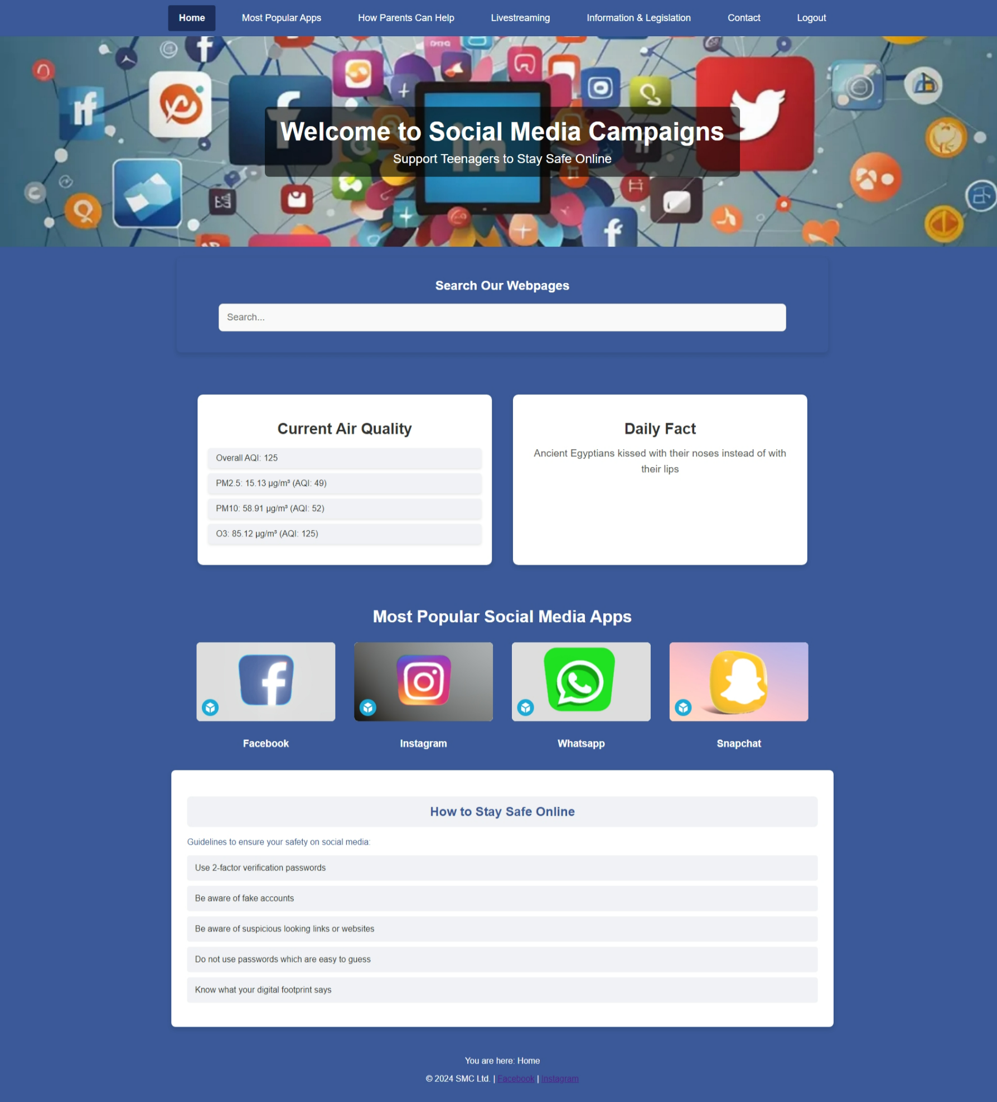

information.html

<!DOCTYPE html>

<html lang="en">

<head>

    <meta charset="UTF-8">

    <meta name="viewport" content="width=device-width, initial-scale=1.0">

    <title>SMC - Information</title>

    <link rel="stylesheet" href="css/styles.css">

    <script src="js/toggle.js" defer></script>

</head>

<body>

    <header>

        <nav>

            <div class="hamburger" onclick="toggleMenu()">

                <div class="bar"></div>

                <div class="bar"></div>

                <div class="bar"></div>

            </div>

            <ul id="nav-links">

                <li><a href="home.html">Home</a></li>

                <li><a href="apps.html">Most Popular Apps</a></li>

                <li><a href="parents.html">How Parents Can Help</a></li>

                <li><a href="livestreaming.html">Livestreaming</a></li>

                <li class="dropdown">

                    <a href="javascript:void(0)" class="dropbtn">Information & Legislation</a>

                    <div class="dropdown-content">

                        <a href="information.html" class="active">Information</a>

                        <a href="legislation.html">Legislation</a>

                    </div>

                </li>

                <li><a href="contact.html">Contact</a></li>

                <li><a href="php/logout.php">Logout</a></li>

            </ul>

        </nav>

    </header>

    <section class="content-section styled-tips">

        <h1>About Our Initiatives</h1>

        <p>We are dedicated to empowering young users by equipping them with the knowledge and tools needed to navigate the digital world safely. Through targeted educational resources, practical tips, and comprehensive campaigns, we aim to foster a culture of responsible and mindful social media usage among teenagers.</p>

        <img src="images/campaigns.jpg" alt="Campaigns" class="campaign-image">

    </section>

    <section class="details-section styled-tips">

        <h2>Our Vision for Safe Digital Spaces</h2>

        <p>Our vision is to create a digital landscape where teenagers can explore social media with confidence, free from threats such as cyberbullying, privacy breaches, or exposure to harmful content. Our initiatives strive to raise awareness about these risks and provide young users with the skills and strategies they need to stay safe while enjoying the benefits of social media.</p>

    </section>

    <!-- Footer -->

    <footer>

        <p>You are here: Information</p>

        <p>&copy; 2024 SMC Ltd. | <a href="https://facebook.com">Facebook</a> | <a href="https://www.instagram.com/">Instagram</a></p>

    </footer>

</body>

</html>

Information Page Screenshot -

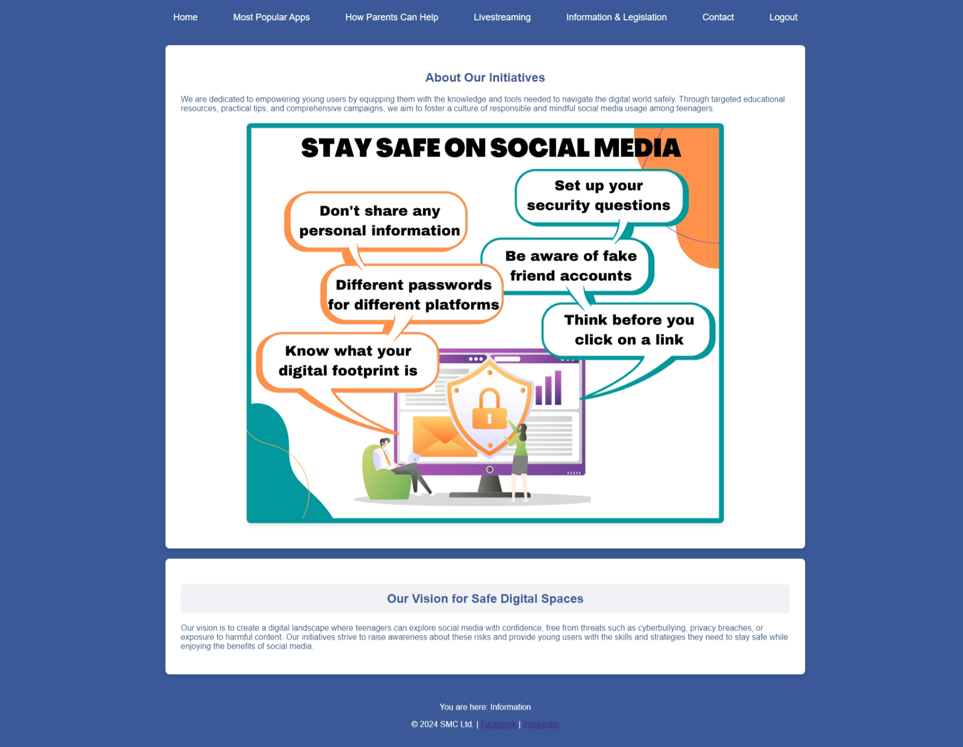

legislation.html

<!DOCTYPE html>

<html lang="en">

<head>

    <meta charset="UTF-8">

    <meta name="viewport" content="width=device-width, initial-scale=1.0">

    <title>SMC - Legislation & Guidance</title>

    <link rel="stylesheet" href="css/styles.css">

    <script src="js/toggle.js" defer></script>

</head>

<body>

    <header>

        <nav>

            <div class="hamburger" onclick="toggleMenu()">

                <div class="bar"></div>

                <div class="bar"></div>

                <div class="bar"></div>

            </div>

            <ul id="nav-links">

                <li><a href="home.html">Home</a></li>

                <li><a href="apps.html">Most Popular Apps</a></li>

                <li><a href="parents.html">How Parents Can Help</a></li>

                <li><a href="livestreaming.html">Livestreaming</a></li>

                <li class="dropdown">

                    <a href="javascript:void(0)" class="dropbtn">Information & Legislation</a>

                    <div class="dropdown-content">

                        <a href="information.html">Information</a>

                        <a href="legislation.html"  class="active">Legislation</a>

                    </div>

                </li>

                <li><a href="contact.html">Contact</a></li>

                <li><a href="php/logout.php">Logout</a></li>

            </ul>

        </nav>

    </header>

    <section class="content-section styled-tips">

        <h1>Online Safety Legislation & Guidance</h1>

        <p>Staying safe online involves understanding the legal frameworks and best practices that govern digital spaces. Explore the essential laws and guidelines that help protect users in the online world.</p>

    </section>

    <section id="legislation-details" class="styled-tips">

        <h2>Essential Online Safety Legislation</h2>

        <ul>

            <li>Children's Online Privacy Protection Act (COPPA) - Protects the privacy of children under 13 by regulating data collection practices.</li>

            <li>General Data Protection Regulation (GDPR) - A robust privacy law in the EU that safeguards user data and grants individuals more control over their personal information.</li>

            <li>Communications Decency Act (CDA) - A U.S. law that provides a framework for regulating obscene and indecent content on the internet.</li>

            <li>Cyberbullying Prevention Laws - Various local and national regulations aimed at preventing harassment and abuse in digital spaces.</li>

            <li>Internet Safety Laws for Schools - Rules and guidelines designed to create a safer online environment for students within educational institutions.</li>

        </ul>

    </section>

    <section id="best-practices" class="styled-tips">

        <h2>Effective Strategies for Safe Social Media Use</h2>

        <p>Adopting safe practices is key to maintaining security on social media platforms. Consider these recommended actions to enhance your online safety:</p>

        <ul>

            <li>Review the terms of service for each platform to understand how your data is used and your rights as a user.</li>

            <li>Create strong, varied passwords for every account and change them regularly to prevent unauthorized access.</li>

            <li>Stay vigilant about suspicious emails or messages and avoid clicking on unknown links.</li>

            <li>Consistently update privacy and security settings to reflect your current comfort level with data sharing.</li>

            <li>Educate young users on the significance of digital privacy, safe online behavior, and recognizing potential threats.</li>

        </ul>

    </section>

    <!-- Footer -->

    <footer>

        <p>You are here: Legislation & Guidance</p>

        <p>&copy; 2024 SMC Ltd. | <a href="https://facebook.com">Facebook</a> | <a href="https://www.instagram.com/">Instagram</a></p>

    </footer>

</body>

</html>

Legislation Page Screenshot -

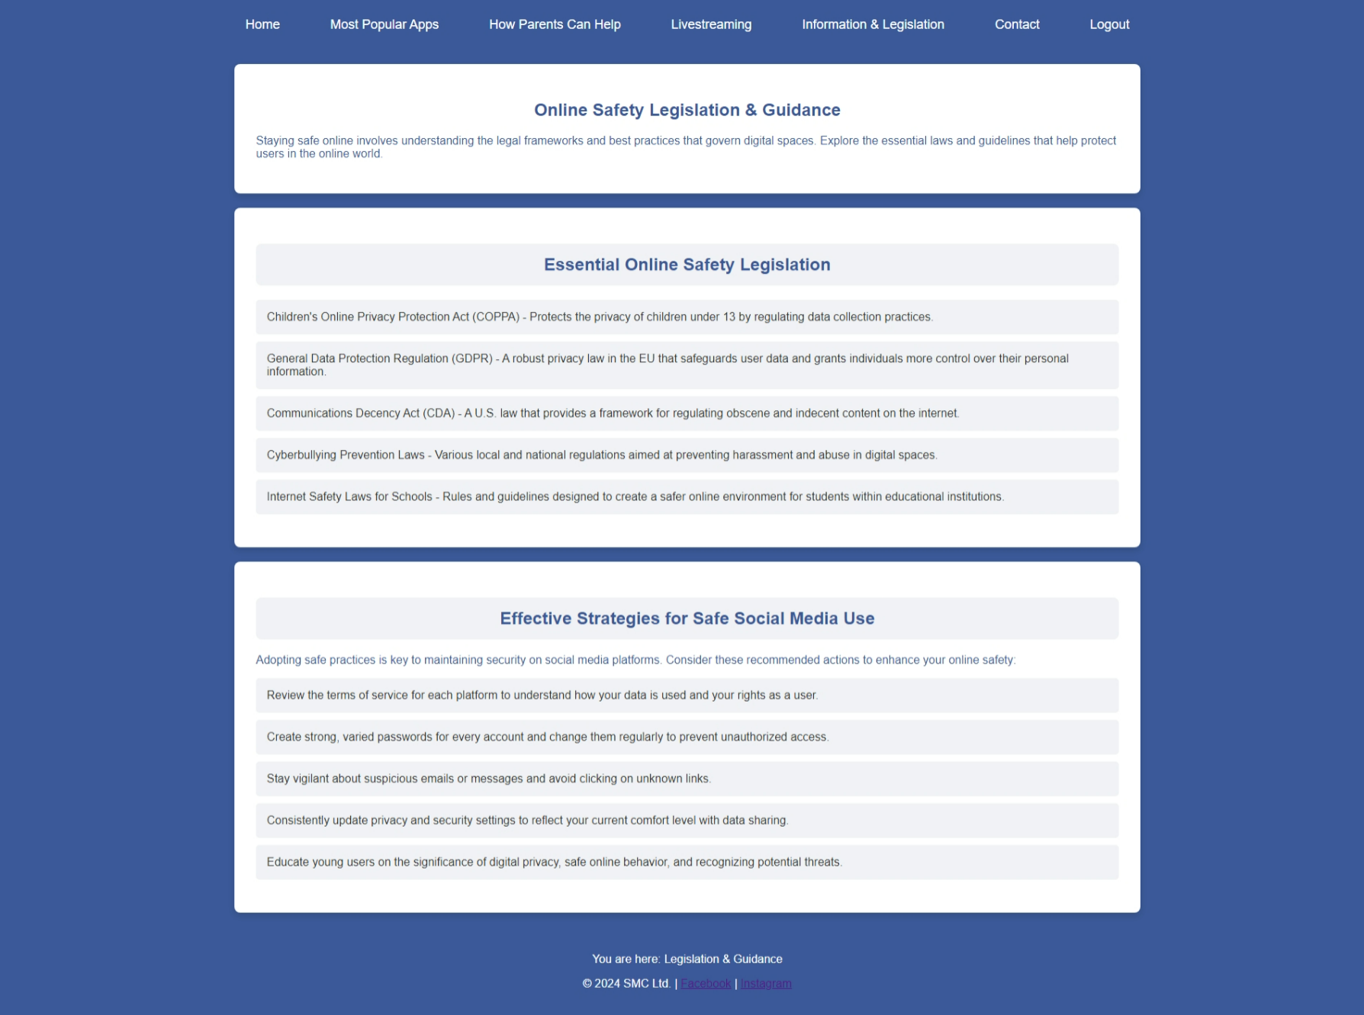

app.html

<!DOCTYPE html>

<html lang="en">

<head>

    <meta charset="UTF-8">

    <meta name="viewport" content="width=device-width, initial-scale=1.0">

    <title>SMC - Most Popular Apps</title>

    <link rel="stylesheet" href="css/styles.css">

    <script src="js/apps.js" defer></script> <!-- Updated JS file name -->

    <script src="js/toggle.js" defer></script>

</head>

<body>

    <header>

        <nav>

            <div class="hamburger" onclick="toggleMenu()">

                <div class="bar"></div>

                <div class="bar"></div>

                <div class="bar"></div>

            </div>

            <ul id="nav-links">

                <li><a href="home.html">Home</a></li>

                <li><a href="apps.html" class="active">Most Popular Apps</a></li>

                <li><a href="parents.html">How Parents Can Help</a></li>

                <li><a href="livestreaming.html">Livestreaming</a></li>

                <li class="dropdown">

                    <a href="javascript:void(0)" class="dropbtn">Information & Legislation</a>

                    <div class="dropdown-content">

                        <a href="information.html">Information</a>

                        <a href="legislation.html">Legislation</a>

                    </div>

                </li>

                <li><a href="contact.html">Contact</a></li>

                <li><a href="php/logout.php">Logout</a></li>

            </ul>

        </nav>

    </header>

    <!-- Static Safety Tips Section -->

    <section class="content-section styled-tips">

        <h1>Most Popular Social Media Apps</h1>

    </section>

    <!-- CRUD Managed Popular Apps Section -->

    <section id="apps-list" class="styled-tips">

        <h2>Manage Popular Apps</h2>

        <ul id="apps">

            <!-- Dynamically populated list of apps -->

        </ul>

        <h3>Add a New App</h3>

        <form id="addAppForm">

            <input type="text" id="newApp" name="app" placeholder="Enter a new app name..." required>

            <input type="submit" value="Add App">

        </form>

    </section>

    <section id="safety-tips" class="styled-tips">

        <h2>Safety Tips</h2>

        <ul>

            <li>Never share personal information online.</li>

            <li>Be cautious of who you connect with.</li>

            <li>Use strong passwords and update them regularly.</li>

            <li>Report any suspicious activity.</li>

            <li>Keep your software up to date.</li>

        </ul>

    </section>

    <!-- Footer -->

    <footer>

        <p>You are here: Most Popular Apps</p>

        <p>&copy; 2024 SMC Ltd. | <a href="https://facebook.com">Facebook</a> | <a href="https://www.instagram.com/">Instagram</a></p>

    </footer>

</body>

</html>

apps.js

async function fetchApps(query = '') {

    const response = await fetch(`php/apps.php?action=view&query=${query}`);

    const apps = await response.json();

    const appsList = document.getElementById('apps');

    appsList.innerHTML = ''; // Clear existing content

    apps.forEach(app => {

        const appItem = document.createElement('li');

        // Create a span for app name

        const appName = document.createElement('span');

        appName.textContent = app.name;

        // Create edit input

        const editInput = document.createElement('input');

        editInput.type = 'text';

        editInput.value = app.name;

        editInput.style.display = 'none';

        editInput.className = 'edit-input'; // Add class for consistent styling

        // Create a button container

        const buttonContainer = document.createElement('div');

        buttonContainer.className = 'button-container'; // Add class for consistent styling

        // Create edit button

        const editButton = document.createElement('button');

        editButton.textContent = 'Edit';

        editButton.className = 'action-button'; // Add class for consistent styling

        editButton.onclick = () => {

            editInput.style.display = 'inline';

            appName.style.display = 'none';

            saveButton.style.display = 'inline';

        };

        // Create save button

        const saveButton = document.createElement('button');

        saveButton.textContent = 'Save';

        saveButton.style.display = 'none';

        saveButton.className = 'action-button'; // Add class for consistent styling

        saveButton.onclick = async () => {

            await updateApp(app.id, editInput.value);

            fetchApps(query);

        };

        // Create delete button

        const deleteButton = document.createElement('button');

        deleteButton.textContent = 'Delete';

        deleteButton.className = 'action-button'; // Add class for consistent styling

        deleteButton.onclick = async () => {

            await deleteApp(app.id);

            fetchApps(query);

        };

        // Append buttons to button container

        buttonContainer.appendChild(editButton);

        buttonContainer.appendChild(saveButton);

        buttonContainer.appendChild(deleteButton);

        // Append elements to app item

        appItem.appendChild(appName);

        appItem.appendChild(editInput);

        appItem.appendChild(buttonContainer);

        // Append app item to list

        appsList.appendChild(appItem);

    });

    appsList.style.display = apps.length ? 'block' : 'none';

}

async function addApp() {

    const newApp = document.getElementById('newApp').value;

    const response = await fetch('php/apps.php', {

        method: 'POST',

        headers: { 'Content-Type': 'application/x-www-form-urlencoded' },

        body: `action=add&name=${encodeURIComponent(newApp)}`

    });

    const result = await response.json();

    alert(result.message);

    document.getElementById('newApp').value = '';

    fetchApps();

}

async function deleteApp(id) {

    const response = await fetch('php/apps.php', {

        method: 'POST',

        headers: { 'Content-Type': 'application/x-www-form-urlencoded' },

        body: `action=delete&id=${id}`

    });

    const result = await response.json();

    alert(result.message);

}

async function updateApp(id, name) {

    const response = await fetch('php/apps.php', {

        method: 'POST',

        headers: { 'Content-Type': 'application/x-www-form-urlencoded' },

        body: `action=edit&id=${id}&name=${encodeURIComponent(name)}`

    });

    const result = await response.json();

    alert(result.message);

}

document.getElementById('addAppForm').addEventListener('submit', function(event) {

    event.preventDefault();

    addApp();

});

fetchApps();  // Initial load of apps

Most popular apps page screenshot –

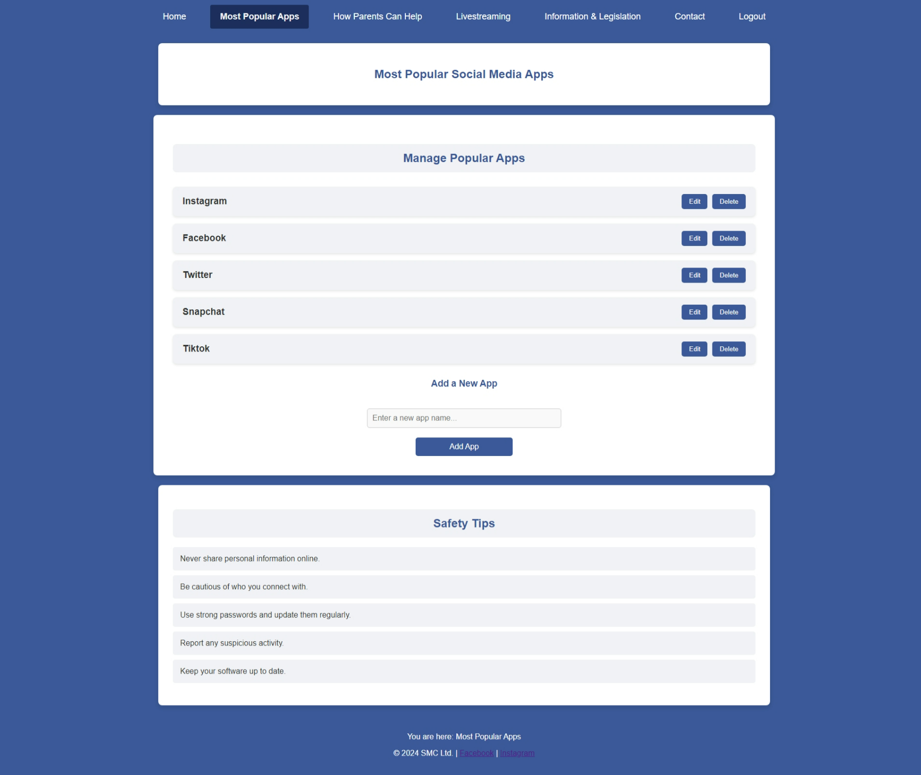

parents.html

<!DOCTYPE html>

<html lang="en">

<head>

    <meta charset="UTF-8">

    <meta name="viewport" content="width=device-width, initial-scale=1.0">

    <title>SMC - How Parents Can Help</title>

    <link rel="stylesheet" href="css/styles.css">

    <script src="js/toggle.js" defer></script>

</head>

<body>

    <header>

        <nav>

            <div class="hamburger" onclick="toggleMenu()">

                <div class="bar"></div>

                <div class="bar"></div>

                <div class="bar"></div>

            </div>

            <ul id="nav-links">

                <li><a href="home.html">Home</a></li>

                <li><a href="apps.html">Most Popular Apps</a></li>

                <li><a href="parents.html"  class="active">How Parents Can Help</a></li>

                <li><a href="livestreaming.html">Livestreaming</a></li>

                <li class="dropdown">

                    <a href="javascript:void(0)" class="dropbtn">Information & Legislation</a>

                    <div class="dropdown-content">

                        <a href="information.html">Information</a>

                        <a href="legislation.html">Legislation</a>

                    </div>

                </li>

                <li><a href="contact.html">Contact</a></li>

                <li><a href="php/logout.php">Logout</a></li>

            </ul>

        </nav>

    </header>

    <section class="content-section styled-tips">

        <h1>Empowering Parents for Safe Social Media Use</h1>

        <p>Discover effective ways to support your teenagers in developing mindful and safe online behaviors.</p>

    </section>

    <section id="tips" class="styled-tips">

        <h2>Essential Advice for Parents to Guide Teens Online</h2>

        <ul>

            <li>Establish clear rules and guidelines for using social media, balancing freedom with safety.</li>

            <li>Educate them about the dangers of oversharing and the importance of protecting personal details.</li>

            <li>Stay engaged with their digital lives by regularly discussing what they post and follow.</li>

            <li>Help them develop critical thinking skills to evaluate the reliability of online content and sources.</li>

            <li>Lead by example—demonstrate responsible and safe online practices that they can emulate.</li>

        </ul>

    </section>

    <!-- Footer -->

    <footer>

        <p>You are here: How Parents Can Help</p>

        <p>&copy; 2024 SMC Ltd. | <a href="https://facebook.com">Facebook</a> | <a href="https://www.instagram.com/">Instagram</a></p>

    </footer>

</body>

</html>

How parents can help page screenshot -

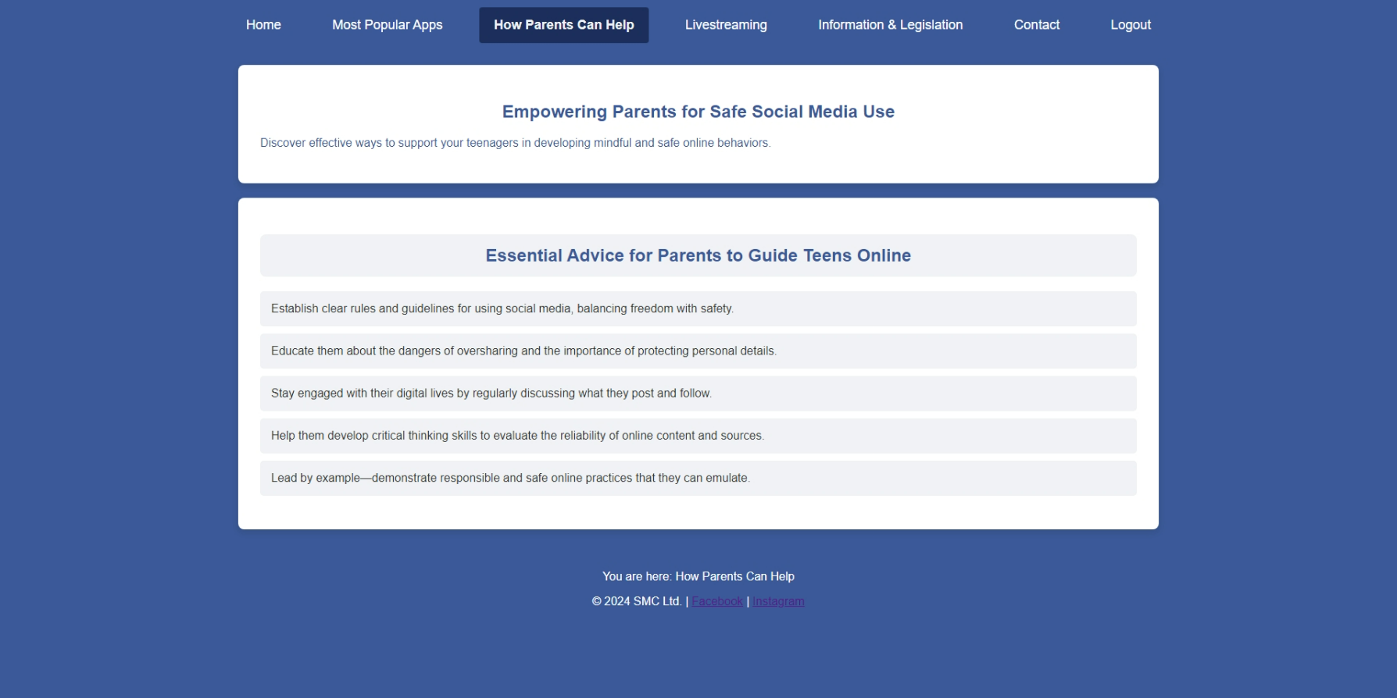

livestreaming.html

<!DOCTYPE html>

<html lang="en">

<head>

    <meta charset="UTF-8">

    <meta name="viewport" content="width=device-width, initial-scale=1.0">

    <title>SMC - Livestreaming</title>

    <link rel="stylesheet" href="css/styles.css">

    <script src="js/toggle.js" defer></script>

</head>

<body>

    <header>

        <nav>

            <div class="hamburger" onclick="toggleMenu()">

                <div class="bar"></div>

                <div class="bar"></div>

                <div class="bar"></div>

            </div>

            <ul id="nav-links">

                <li><a href="home.html">Home</a></li>

                <li><a href="apps.html">Most Popular Apps</a></li>

                <li><a href="parents.html">How Parents Can Help</a></li>

                <li><a href="livestreaming.html"  class="active">Livestreaming</a></li>

                <li class="dropdown">

                    <a href="javascript:void(0)" class="dropbtn">Information & Legislation</a>

                    <div class="dropdown-content">

                        <a href="information.html">Information</a>

                        <a href="legislation.html">Legislation</a>

                    </div>

                </li>

                <li><a href="contact.html">Contact</a></li>

                <li><a href="php/logout.php">Logout</a></li>

            </ul>

        </nav>

    </header>

    <section class="content-section styled-tips">

        <h1>Safe Livestreaming Practices</h1>

        <p>Livestreaming is a fantastic way to connect and share experiences in real-time, but it's crucial to prioritize your safety and privacy while doing so.</p>

        <img src="images/live-streaming.png" alt="Livestreaming Safety" class="campaign-image">

    </section>

    <section id="livestreaming-tips" class="styled-tips">

        <h2>Tips for Secure and Responsible Livestreaming</h2>

        <ul>

            <li>Consider the content you are sharing and ensure it's appropriate for your audience.</li>

            <li>Adjust your privacy settings to control who has access to your livestreams.</li>

            <li>Avoid sharing personal or sensitive information while broadcasting live.</li>

            <li>Be prepared to block or report any viewers who behave inappropriately or violate your guidelines.</li>

            <li>Limit the duration of your livestreams to reduce the risk of revealing too much personal information.</li>

        </ul>

    </section>

    <!-- Footer -->

    <footer>

        <p>You are here: Livestreaming</p>

        <p>&copy; 2024 SMC Ltd. | <a href="https://facebook.com">Facebook</a> | <a href="https://www.instagram.com/">Instagram</a></p>

    </footer>

</body>

</html>

Livestreaming Safety Screenshot –

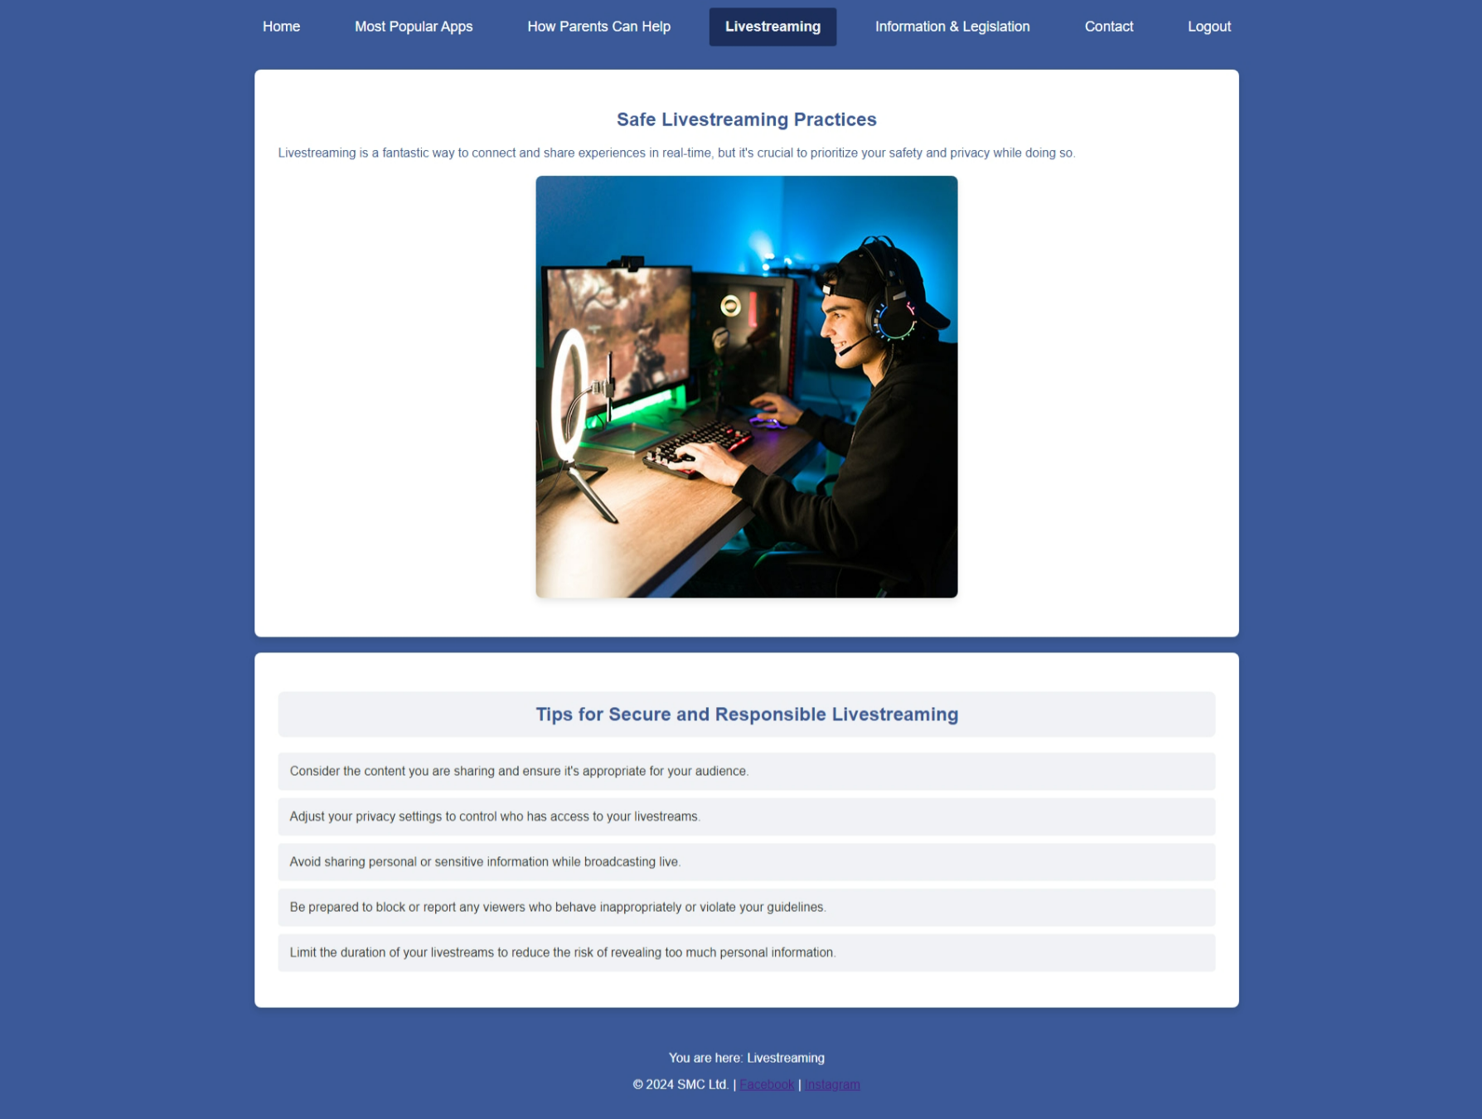

contact.html

<!DOCTYPE html>

<html lang="en">

<head>

    <meta charset="UTF-8">

    <meta name="viewport" content="width=device-width, initial-scale=1.0">

    <title>SMC - Contact</title>

    <link rel="stylesheet" href="css/styles.css">

    <script src="js/toggle.js" defer></script>

</head>

<body>

    <header>

        <nav>

            <div class="hamburger" onclick="toggleMenu()">

                <div class="bar"></div>

                <div class="bar"></div>

                <div class="bar"></div>

            </div>

            <ul id="nav-links">

                <li><a href="home.html">Home</a></li>

                <li><a href="apps.html">Most Popular Apps</a></li>

                <li><a href="parents.html">How Parents Can Help</a></li>

                <li><a href="livestreaming.html">Livestreaming</a></li>

                <li class="dropdown">

                    <a href="javascript:void(0)" class="dropbtn">Information & Legislation</a>

                    <div class="dropdown-content">

                        <a href="information.html">Information</a>

                        <a href="legislation.html">Legislation</a>

                    </div>

                </li>

                <li><a href="contact.html" class="active">Contact</a></li>

                <li><a href="php/logout.php">Logout</a></li>

            </ul>

        </nav>

    </header>

    <section class="content-section styled-tips">

        <h1>Contact Us</h1>

        <p>If you have any questions or concerns, feel free to reach out to us through the form below.</p>

    </section>

    <section id="contact-form" class="styled-tips">

        <h2>Get in Touch</h2>

        <form action="php/contact.php" method="POST">

            <label for="name">Name:</label>

            <input type="text" id="name" name="name" required>

            <label for="email">Email:</label>

            <input type="email" id="email" name="email" required>

            <label for="message">Message:</label>

            <textarea id="message" name="message" rows="5" required></textarea>

            <input type="submit" value="Send" class="submit-button">

        </form>

        <p><a href="privacy-policy.html">Privacy Policy</a></p>

    </section>

    <!-- Footer -->

    <footer>

        <p>You are here: Contact</p>

        <p>&copy; 2024 SMC Ltd. | <a href="https://facebook.com">Facebook</a> | <a href="https://twitter.com">Twitter</a></p>

    </footer>

</body>

</html>

Contact page screenshot -

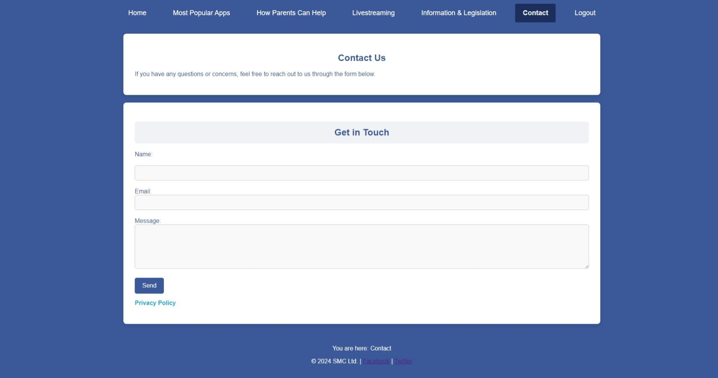

privacy-policy.html

<!DOCTYPE html>

<html lang="en">

<head>

    <meta charset="UTF-8">

    <meta name="viewport" content="width=device-width, initial-scale=1.0">

    <title>Privacy Policy</title>

    <link rel="stylesheet" href="css/styles.css">

</head>

<body>

    <header>

        <nav>

            <ul>

                <li><a href="home.html">Home</a></li>

                <li><a href="privacy-policy.html" class="active">Privacy Policy</a></li>

                <li><a href="contact.html">Contact</a></li>

            </ul>

        </nav>

    </header>

    <section class="styled-tips">

        <h1>Privacy Statement</h1>

        <p>Effective Date: 2/09/2024</p>

        <h2>1. Overview</h2>

        <p>Welcome to Social Media Campaigns Ltd. This privacy statement outlines how we handle, use, and safeguard the personal data you provide when accessing our website and its services.</p>

        <h2>2. Data We Gather</h2>

        <p>We collect different types of personal information that you provide to us directly, such as when you sign up on our platform, show interest in our services, engage in activities on the website, or reach out to us directly.</p>

        <ul>

            <li><strong>Personal Information:</strong> Includes your name, email address, and contact details.</li>

            <li><strong>Usage Information:</strong> Comprises IP addresses, browser types, and pages you visit.</li>

            <li><strong>Cookie Data:</strong> Utilizes session cookies, preference cookies, and security cookies.</li>

        </ul>

        <h2>3. Purpose of Data Usage</h2>

        <p>We use the data we collect or receive for various purposes, including:</p>

        <ul>

            <li>To deliver and manage our services efficiently.</li>

            <li>To communicate administrative information to you.</li>

            <li>To secure our services and enforce our legal terms and policies.</li>

            <li>To respond to lawful requests and mitigate potential risks.</li>

        </ul>

        <h2>4. Information Sharing Practices</h2>

        <p>We may share your personal information in certain circumstances, such as:</p>

        <ul>

            <li><strong>With Third-Party Partners:</strong> We may share your data with third-party vendors, contractors, and agents who provide services on our behalf.</li>

            <li><strong>For Legal Compliance:</strong> We may disclose your data when it is necessary to comply with legal obligations, protect the safety of users or others, address fraud concerns, or respond to government inquiries.</li>

        </ul>

        <h2>5. Data Security Measures</h2>

        <p>We employ various administrative, technical, and physical safeguards to secure your personal data. However, please be aware that no method of online transmission or storage is entirely foolproof.</p>

        <h2>6. Your Privacy Rights</h2>

        <p>As a user, you are entitled to several rights regarding your personal data, such as:</p>

        <ul>

            <li><strong>Right to Access:</strong> You are entitled to request a copy of the personal data we hold about you.</li>

            <li><strong>Right to Correction:</strong> You have the right to request corrections to any inaccurate or incomplete information.</li>

            <li><strong>Right to Deletion:</strong> You can request that we delete your personal data under specific circumstances.</li>

        </ul>

        <h2>7. Policy Modifications</h2>

        <p>We may revise this privacy statement periodically. Any updates will be posted on this page to keep you informed of how we protect your data.</p>

        <h2>8. Contact Information</h2>

        <p>If you have any questions or concerns regarding this privacy policy, please reach out to us:</p>

        <p>Email: support@smc_website.com</p>

        <p>Phone: +123 456 7890</p>

    </section>

    <!-- Footer -->

    <footer>

        <p>You are here: Privacy Policy</p>

        <p>&copy; 2024 SMC Ltd. | <a href="https://facebook.com">Facebook</a> | <a href="https://www.instagram.com/">Instagram</a></p>

    </footer>

</body>

</html>

Privacy Policy Screenshot -

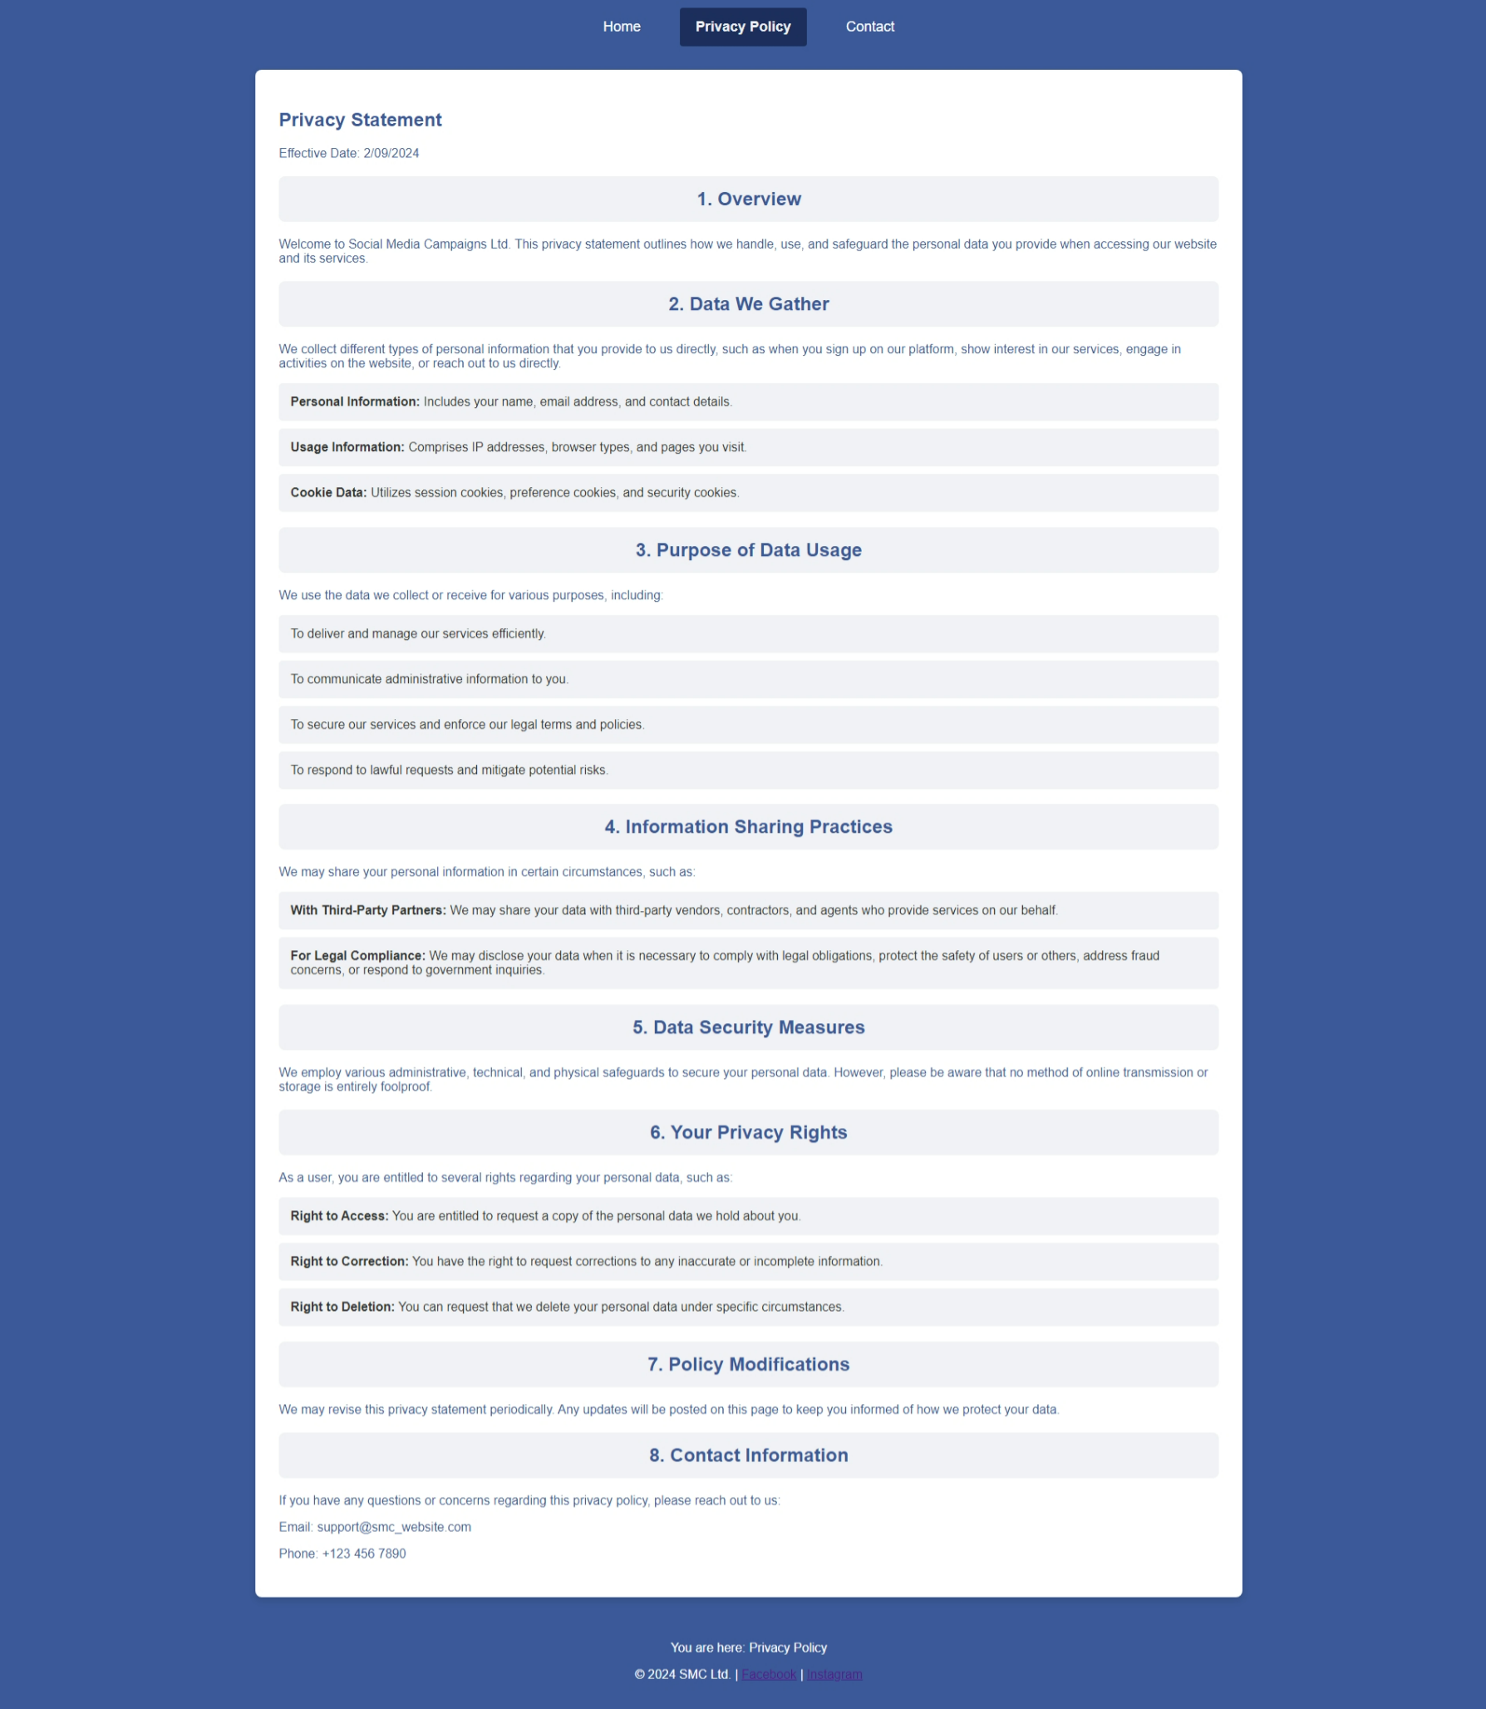

**Task 2** –

My CSS file - style.css

/* General styles */

body {

    font-family: Arial, sans-serif;

    background-color: #3b5998; /* Facebook Blue */

    color: #fff;

    margin: 0;

    padding: 0;

    overflow-x: hidden;

    text-align: center;

}

header {

    background-color: #3b5998; /* Facebook Blue */

    position: relative;

    padding: 10px 0;

    z-index: 1000;

}

header nav {

    display: flex;

    align-items: center;

    justify-content: center;

}

header nav ul {

    display: flex;

    justify-content: center;

    align-items: center;

    list-style: none;

    margin: 0;

    padding: 0;

}

header nav ul li {

    margin: 0 15px;

    position: relative; /* Needed for dropdown */

}

header nav ul li a {

    color: white;

    text-decoration: none;

    padding: 14px 20px;

    display: block;

    font-size: 18px;

    transition: background-color 0.3s ease;

}

/* Active link styling */

header nav ul li a.active {

    background-color: #1c2e5c; /* A darker shade of Facebook blue */

    color: #f0f2f5; /* Lighter color for text contrast */

    border-radius: 4px; /* Rounded corners for the active link */

    font-weight: bold; /* Bold text to stand out */

}

/* Dropdown Menu */

header nav ul li .dropdown-content {

    display: none; /* Hide by default */

    position: absolute;

    background-color: #3b5998;

    min-width: 160px;

    box-shadow: 0px 8px 16px 0px rgba(0, 0, 0, 0.2);

    z-index: 1001;

    top: 100%; /* Position it below the parent */

    left: 50%;

    transform: translateX(-50%); /* Center-align dropdown */

}

header nav ul li .dropdown-content a {

    color: white;

    padding: 12px 16px;

    text-decoration: none;

    display: block;

    text-align: left; /* Align text to the left */

}

header nav ul li .dropdown-content a:hover {

    background-color: #444; /* Slightly darker on hover */

}

header nav ul li:hover .dropdown-content {

    display: block; /* Show on hover */

}

/* Hamburger Menu */

.hamburger {

    display: none;

    cursor: pointer;

    padding: 15px;

}

.hamburger .bar {

    display: block;

    width: 30px;

    height: 4px;

    margin: 5px auto;

    background-color: white;

}

/* Responsive Navigation */

@media (max-width: 768px) {

    .hamburger {

        display: block; /* Show hamburger on small screens */

    }

    header nav ul {

        display: none; /* Hide the menu by default */

        flex-direction: column;

        width: 100%;

        background-color: #3b5998;

        position: absolute;

        top: 60px; /* Position it below the header */

        left: 0;

        padding: 0;

        margin: 0;

        z-index: 1000;

    }

    header nav ul.show {

        display: flex; /* Show the menu when toggled */

    }

    header nav ul li {

        width: 100%;

        text-align: center;

        margin: 0; /* Remove margin for full width */

    }

    header nav ul li a {

        padding: 15px 20px;

        font-size: 18px;

        display: block;

    }

    header nav ul li .dropdown-content {

        position: static; /* Reposition for mobile view */

        transform: none; /* Remove transform for center alignment */

        box-shadow: none; /* Remove shadow */

    }

}

/* Hero section */

.hero-section {

    background-image: url('images/social_media.jpg');

    background-size: cover;

    background-position: center;

    height: 400px;

    display: flex;

    justify-content: center;

    align-items: center;

    color: white;

    margin-bottom: 20px; /* Consistent spacing */

    position: relative; /* Ensure relative positioning for child elements */

}

/* Hero content styling */

.hero-content {

    background-color: rgba(0, 0, 0, 0.6); /* Translucent black background for readability */

    padding: 20px 30px; /* Add padding for spacing */

    border-radius: 8px; /* Rounded corners */

    text-align: center;

    max-width: 80%; /* Limit width for better readability */

    margin: 0 auto; /* Center horizontally */

}

.hero-content h1 {

    font-size: 3em; /* Larger font size for better readability */

    font-weight: bold;

    margin: 0 0 10px 0; /* Add some space below the heading */

}

.hero-content p {

    font-size: 1.5em; /* Larger font size for better readability */

    margin: 10px 0 0 0; /* Add some space above the paragraph */

}

/* Card Styles */

.card {

    background-color: white;

    color: #3b5998;

    padding: 20px;

    border-radius: 8px;

    box-shadow: 0 4px 8px rgba(0, 0, 0, 0.1);

    margin: 10px;

    text-align: center;

}

/* General styles for the info cards section */

.info-cards {

    display: flex;

    justify-content: space-around;

    flex-wrap: wrap; /* Allow wrapping on smaller screens */

    margin: 40px auto;

    max-width: 1200px; /* Center align and limit the max width */

    padding: 20px;

}

/* Individual Info Card Styling */

.info-card {

    background-color: #ffffff; /* White background for contrast */

    color: #3b5998; /* Consistent text color */

    border-radius: 10px; /* Rounded corners for a modern look */

    padding: 20px; /* Padding inside the card */

    margin: 20px; /* Margin around each card */

    flex: 1; /* Make cards flexible */

    min-width: 280px; /* Minimum width to ensure cards are not too small */

    box-shadow: 0 4px 8px rgba(0, 0, 0, 0.1); /* Subtle shadow for depth */

    text-align: center; /* Center text inside the cards */

    transition: transform 0.2s ease, box-shadow 0.2s ease; /* Smooth transitions for hover effects */

}

/* Hover Effects for Info Cards */

.info-card:hover {

    transform: translateY(-5px); /* Slight lift effect */

    box-shadow: 0 8px 16px rgba(0, 0, 0, 0.2); /* Stronger shadow on hover */

}

/* Heading Styles */

.info-card h3 {

    font-size: 1.8em; /* Increase font size for better visibility */

    margin-bottom: 15px; /* Space below the heading */

    color: #333; /* Darker color for better contrast */

}

/* Paragraph (Content) Styles */

.info-card p {

    font-size: 1.2em; /* Increase font size for readability */

    color: #555; /* Slightly darker color for text */

    line-height: 1.6; /* Improve line height for readability */

    margin: 10px 0; /* Space around the text */

}

/* Social Media Cards */

.social-media-cards {

    display: flex;

    justify-content: space-around;

    flex-wrap: wrap;

    margin: 0 auto 20px auto;

    max-width: 1200px;

}

.social-media-card {

    flex: 1;

    margin: 0 10px; /* Consistent spacing between cards */

    max-width: 22%;

}

.social-media-card iframe {

    max-width: 100%;

    height: 150px;

    border-radius: 8px;

    margin-bottom: 10px;

}

/* Safety Tips Section */

.styled-tips {

    background-color: #fff; /* Ensure white background */

    color: #3b5998; /* Text color consistent with theme */

    padding: 30px; /* More padding for breathing space */

    margin: 20px auto; /* Center-align sections */

    max-width: 1200px; /* Limit width for readability */

    border-radius: 8px; /* Rounded corners for aesthetics */

    box-shadow: 0 4px 8px rgba(0, 0, 0, 0.1); /* Subtle shadow for depth */

    text-align: left; /* Left-align text for content readability */

}

/* Heading Styling */

.styled-tips h2 {

    color: #3b5998; /* Facebook blue color for the heading */

    background-color: #f0f2f5; /* Light gray background to distinguish the heading */

    padding: 15px; /* Padding for spacing */

    border-radius: 8px; /* Rounded corners */

    margin-bottom: 20px; /* Margin below the heading */

    text-align: center; /* Center the heading text */

}

/* Content Styling */

.styled-tips .tips-content {

    margin: 0 auto;

    max-width: 800px;

    color: #333; /* Darker color for better readability */

}

.styled-tips .tips-content p {

    margin-bottom: 20px;

    color: #3b5998; /* Use the same blue color for the paragraph text */

}

.styled-tips ul {

    list-style-type: none;

    padding: 0;

}

.styled-tips ul li {

    background: #f0f2f5; /* Light gray background for list items */

    margin: 10px 0;

    padding: 15px;

    border-radius: 5px;

    color: #333; /* Darker text color for readability */

    text-align: left; /* Align text to the left */

}

/* Footer */

footer {

    color: white;

    text-align: center;

    padding: 20px;

}

/* Search Bar */

input[type="text"] {

    width: 80%;

    padding: 10px;

    margin: 20px auto;

    display: block;

    border-radius: 5px;

    border: 1px solid #ccc;

}

input[type="text"]:focus {

    outline: none;

    border-color: #3b5998;

}

/* Other styles */

section h2 {

    color: #fff;

    margin-bottom: 20px;

}

/* Search Bar Section */

#search {

    margin: 20px auto;

    padding: 20px;

    background-color: #3b5998; /* Same blue background as the rest */

    border-radius: 8px;

    max-width: 1200px; /* Limit the width for better readability */

    box-shadow: 0 4px 8px rgba(0, 0, 0, 0.1); /* Subtle shadow for depth */

    text-align: center;

}

#search h2 {

    color: #fff;

    margin-bottom: 20px;

}

/* Input Styling */

#search input[type="text"] {

    width: 90%;

    padding: 15px;

    margin: 0 auto 20px auto;

    box-sizing: border-box;

    font-size: 18px;

    border: 1px solid #ccc;

    border-radius: 8px;

    display: block;

}

#search input[type="text"]:focus {

    outline: none;

    border-color: #3b5998;

}

/* Search Results Styling */

#searchResults {

    background-color: #fff; /* White background for contrast */

    border: 1px solid #ddd;

    max-height: 300px; /* Max height with scroll */

    overflow-y: auto; /* Scroll when content overflows */

    box-shadow: 0px 4px 8px rgba(0, 0, 0, 0.1); /* Add subtle shadow */

    border-radius: 8px; /* Rounded corners for a modern look */

    padding: 10px; /* Padding around the container */

    margin-top: 10px; /* Space above the container */

    text-align: left; /* Align text to the left */

    width: 90%;

    margin: 0 auto;

}

/* Individual Search Result Item */

.search-result-item {

    color: #333;

    padding: 12px 16px;

    text-decoration: none;

    display: block;

    cursor: pointer;

    background-color: #f9f9f9; /* Light background for items */

    margin-bottom: 10px; /* Space between items */

    border-radius: 5px; /* Rounded corners for items */

    transition: background-color 0.3s ease, transform 0.2s ease; /* Smooth transitions */

}

.search-result-item:hover {

    background-color: #f1f1f1; /* Change background on hover */

    transform: translateY(-2px); /* Lift effect on hover */

}

/* Placeholder for empty search results */

#searchResults:empty {

    display: none; /* Hide container if empty */

}

/* Styles for Air Quality List */

.air-quality-list {

    list-style-type: none; /* Remove default bullet points */

    padding: 0; /* Remove padding */

    margin: 20px 0; /* Add margin for spacing */

    text-align: left; /* Align text to the left for better readability */

}

.air-quality-list li {

    background-color: #f0f2f5; /* Light background for list items */

    padding: 10px 15px; /* Padding inside each list item */

    margin-bottom: 10px; /* Space between list items */

    border-radius: 5px; /* Rounded corners */

    color: #333; /* Darker color for text readability */

    box-shadow: 0 2px 4px rgba(0, 0, 0, 0.1); /* Subtle shadow for depth */

}

/* Section Heading Style */

.section-heading {

    font-size: 2em; /* Increase the font size */

    color: #ffffff; /* Facebook Blue color */

    text-align: center; /* Center-align the heading */

    margin-bottom: 30px; /* Space below the heading */

    margin-top: 20px; /* Space above the heading */

    font-weight: bold; /* Make the text bold */

}

/* General styling for content sections */

.content-section, .details-section, #tips, #apps-list, #add-tip, #livestreaming-tips, #legislation-details, #best-practices {

    background-color: #fff; /* Ensure white background */

    color: #3b5998; /* Text color consistent with theme */

    padding: 30px; /* More padding for breathing space */

    margin: 20px auto; /* Center-align sections */

    max-width: 1200px; /* Limit width for readability */

    border-radius: 8px; /* Rounded corners for aesthetics */

    box-shadow: 0 4px 8px rgba(0, 0, 0, 0.1); /* Subtle shadow for depth */

    text-align: left; /* Left-align text for content readability */

}

/* Consistent heading styles across all pages */

.content-section h1, .details-section h2, #tips h2, #apps-list h2, #add-tip h2, #livestreaming-tips h2, #legislation-details h2, #best-practices h2 {

    color: #3b5998; /* Consistent heading color */

    font-weight: bold; /* Bold text */

    margin-bottom: 20px; /* Space below the heading */

    text-align: center; /* Center-align headings */

}

/* Form Input and Textarea Styling */

input[type="text"], input[type="email"], input[type="password"], textarea {

    width: 100%; /* Full width for inputs */

    padding: 10px; /* Padding for better UX */

    margin-bottom: 20px; /* Spacing between fields */

    border-radius: 5px; /* Rounded corners for inputs */

    border: 1px solid #ccc; /* Subtle border */

    font-size: 16px; /* Consistent font size */

    background-color: #f9f9f9; /* Light background for inputs */

    box-sizing: border-box; /* Include padding and border in width */

}

/* Input and Textarea Focus Styling */

input[type="text"]:focus, input[type="email"]:focus, input[type="password"]:focus, textarea:focus {

    outline: none; /* Remove default outline */

    border-color: #3b5998; /* Focus color */

    background-color: #fff; /* Change background on focus */

}

/* Center-align the image in the content section */

.campaign-image {

    display: block; /* Make the image a block element */

    margin: 20px auto; /* Center the image horizontally and add margin */

    max-width: 80%; /* Make sure the image doesn't overflow */

    border-radius: 8px; /* Optional: Rounded corners for aesthetics */

    box-shadow: 0 4px 8px rgba(0, 0, 0, 0.1); /* Optional: Add shadow for depth */

}

/* Input and Textarea Styling */

#contact-form input[type="text"],

#contact-form input[type="email"],

#contact-form textarea {

    width: 100%; /* Full width for inputs */

    padding: 10px; /* Padding for better UX */

    margin-bottom: 20px; /* Spacing between fields */

    border-radius: 5px; /* Rounded corners for inputs */

    border: 1px solid #ccc; /* Subtle border */

    font-size: 16px; /* Consistent font size */

    background-color: #f9f9f9; /* Light background for inputs */

    box-sizing: border-box; /* Include padding and border in width */

}

/* Input and Textarea Focus Styling */

#contact-form input[type="text"]:focus,

#contact-form input[type="email"]:focus,

#contact-form textarea:focus {

    outline: none; /* Remove default outline */

    border-color: #3b5998; /* Focus color */

    background-color: #fff; /* Change background on focus */

}

/* Submit Button Styling */

.submit-button {

    background-color: #3b5998; /* Button background color */

    color: white; /* Button text color */

    padding: 12px 20px; /* Button padding */

    border: none; /* Remove default border */

    border-radius: 5px; /* Rounded corners for button */

    cursor: pointer; /* Change cursor on hover */

    font-size: 16px; /* Font size for button */

    transition: background-color 0.3s ease; /* Smooth hover effect */

}

/* Submit Button Hover Effect */

.submit-button:hover {

    background-color: #2d4373; /* Darker shade on hover */

}

/* Privacy Policy Link Styling */

#contact-form p a {

    color: #1CAAD9; /* Link color */

    text-decoration: none; /* Remove underline */

    font-weight: bold; /* Bold text for link */

}

#contact-form p a:hover {

    text-decoration: underline; /* Underline on hover */

}

/* Container for the Apps Section */

#apps-list {

    background-color: #fff; /* White background for contrast */

    color: #3b5998; /* Consistent text color */

    padding: 40px; /* Increased padding inside the section */

    margin: 20px auto; /* Center-align the section */

    max-width: 1200px; /* Limit width for better readability */

    border-radius: 8px; /* Rounded corners for modern look */

    box-shadow: 0 4px 8px rgba(0, 0, 0, 0.1); /* Subtle shadow for depth */

    text-align: center; /* Center-align content */

}

/* Styling the List of Apps */

#apps {

    list-style-type: none; /* Remove bullet points */

    padding: 0; /* Remove default padding */

    margin: 30px 0; /* Margin for spacing */

    text-align: left; /* Align text to the left for better readability */

}

/* Individual App Container */

#apps li {

    background-color: #f0f2f5; /* Light grey background for each app */

    padding: 15px 20px; /* Padding inside each app container */

    margin-bottom: 15px; /* Space between apps */

    border-radius: 8px; /* Rounded corners for aesthetics */

    display: flex; /* Flexbox for layout */

    align-items: center; /* Align items vertically */

    justify-content: space-between; /* Space between app name and buttons */

    box-shadow: 0 2px 4px rgba(0, 0, 0, 0.1); /* Subtle shadow for depth */

    transition: transform 0.2s ease, box-shadow 0.2s ease; /* Smooth transition */

}

#apps li:hover {

    transform: translateY(-3px); /* Slight lift on hover */

    box-shadow: 0 6px 12px rgba(0, 0, 0, 0.15); /* Stronger shadow on hover */

}

/* App Name Styling */

#apps li span {

    font-size: 1.2em; /* Increase font size for better visibility */

    font-weight: bold; /* Bold text for app name */

    flex: 1; /* Take available space */

    margin-right: 20px; /* Space between app name and buttons */

}

/* Button Container Styling */

#apps li .button-container {

    display: flex; /* Flexbox for layout */

    gap: 10px; /* Gap between buttons */

}

/* Button Styling */

#apps li button {

    background-color: #3b5998; /* Facebook blue for buttons */

    color: #fff; /* White text color */

    border: none; /* Remove default border */

    padding: 8px 15px; /* Padding for buttons */

    border-radius: 5px; /* Rounded corners for buttons */

    cursor: pointer; /* Pointer cursor on hover */

    transition: background-color 0.3s ease; /* Smooth transition for hover */

}

/* Button Hover Effect */

#apps li button:hover {

    background-color: #2d4373; /* Darker shade on hover */

}

/* Form Styling */

#addAppForm {

    margin-top: 20px; /* Space above the form */

    display: flex; /* Flexbox for layout */

    flex-direction: column; /* Stack items vertically */

    align-items: center; /* Center items horizontally */

    gap: 10px; /* Gap between input and button */

}

/* Input Field for Adding New App */

#addAppForm input[type="text"] {

    width: 100%; /* Full width for better spacing */

    max-width: 400px; /* Maximum width to limit the input size */

    padding: 10px; /* Padding inside input */

    margin-bottom: 10px; /* Margin below input */

    border-radius: 5px; /* Rounded corners */

    border: 1px solid #ccc; /* Subtle border */

    font-size: 16px; /* Consistent font size */

    box-sizing: border-box; /* Include padding in width */

}

/* Centered Add Button Styling */

#addAppForm input[type="submit"] {

    background-color: #3b5998; /* Button background color */

    color: #fff; /* Button text color */

    border: none; /* Remove default border */

    padding: 10px 20px; /* Padding for button */

    border-radius: 5px; /* Rounded corners */

    cursor: pointer; /* Pointer cursor on hover */

    font-size: 16px; /* Consistent font size */

    transition: background-color 0.3s ease; /* Smooth transition for hover */

    width: 200px; /* Fixed width for consistency */

    text-align: center; /* Center-align button text */

}

/* Add Button Hover Effect */

#addAppForm input[type="submit"]:hover {

    background-color: #2d4373; /* Darker shade on hover */

}

My sql query to create database-

CREATE DATABASE smcdb;

USE smcdb;

CREATE TABLE members (

    id INT AUTO_INCREMENT PRIMARY KEY,

    first_name VARCHAR(100) NOT NULL,

    surname VARCHAR(100) NOT NULL,

    email VARCHAR(100) NOT NULL UNIQUE,

    password VARCHAR(255) NOT NULL,

    login_attempts INT DEFAULT 0,

    lock_time TIMESTAMP NULL DEFAULT NULL

);

CREATE TABLE contacts (

    id INT AUTO_INCREMENT PRIMARY KEY,

    name VARCHAR(255) NOT NULL,

    email VARCHAR(255) NOT NULL,

    message TEXT NOT NULL,

    submitted_at TIMESTAMP DEFAULT CURRENT_TIMESTAMP

);

CREATE TABLE popular_apps (

    id INT AUTO_INCREMENT PRIMARY KEY,

    name VARCHAR(255) NOT NULL,

    time_created TIMESTAMP DEFAULT CURRENT_TIMESTAMP

);

INSERT INTO `popular_apps` (`name`) VALUES

('Facebook'),

('Instagram'),

('Twitter'),

('Snapchat'),

('TikTok');

Screenshots of my database -

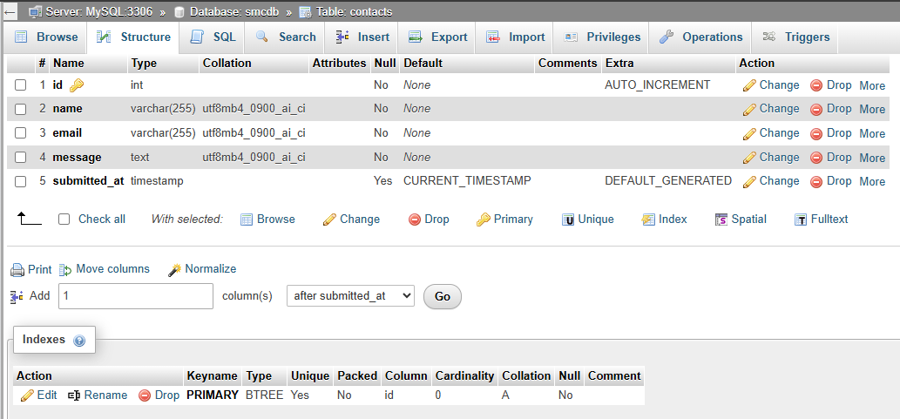

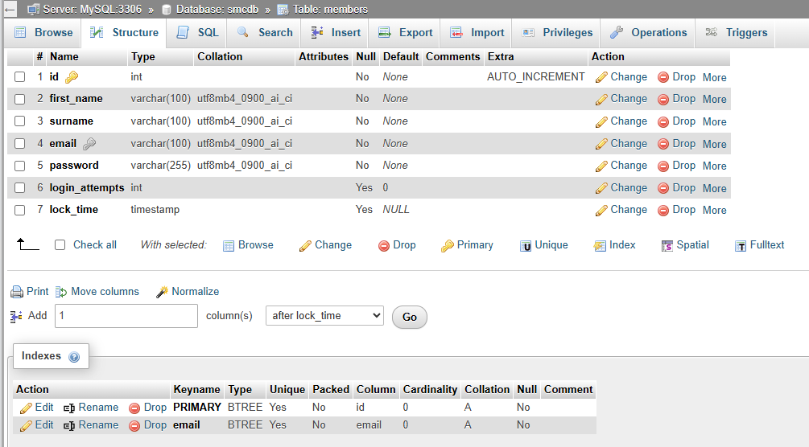

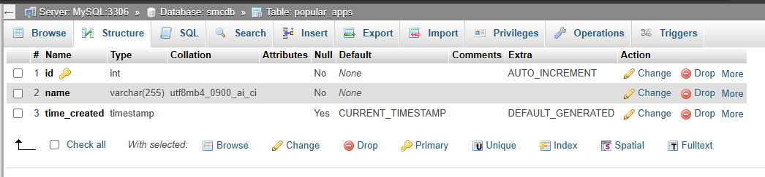

PHP codes for backend–

index.php – This is the starting point of this website. If user is already loged in it will redirect to homepage otherwise it’ll direct to login page

<?php

session_start();

if (isset($_SESSION['email'])) {

    // User is logged in, redirect to home.html

    header("Location: home.html");

} else {

    // User is not logged in, redirect to login.html

    header("Location: login.html");

}

exit();

?>

config.php – Defines the connection to the MySQL database.

<?php

$servername = "localhost";

$username = "root";

$password = "";

$dbname = "smcdb";

// Create connection

$conn = new mysqli($servername, $username, $password, $dbname);

// Check connection

if ($conn->connect_error) {

    die("Connection failed: " . $conn->connect_error);

}

?>

contact.php- Handles form submissions and input sanitization in contact.html page

<?php

// Include the database configuration file

include('config.php');

// Check if the form is submitted

if ($_SERVER['REQUEST_METHOD'] == 'POST') {

    // Get the form data

    $name = mysqli_real_escape_string($conn, $_POST['name']);

    $email = mysqli_real_escape_string($conn, $_POST['email']);

    $message = mysqli_real_escape_string($conn, $_POST['message']);

    // Insert the data into the database

    $query = "INSERT INTO contacts (name, email, message) VALUES ('$name', '$email', '$message')";

    if (!filter_var($email, FILTER_VALIDATE_EMAIL)) {

        echo "<script>

                alert('Invalid email address.');

                window.location.href='../contact.html';

              </script>";

        exit();

    }

    if (mysqli_query($conn, $query)) {

        // Redirect to a thank you page or show a success message

        echo "<script>

                alert('Thank you for getting in touch!');

                window.location.href='../contact.html';

              </script>";

    } else {

        // Handle the error if the query fails

        echo "<script>

                alert('There was an error submitting your message. Please try again.');

                window.location.href='../contact.html';

              </script>";

    }

}

?>

login.php - Password verification, session initiation, login attempts tracking, and account lockout functionality

<?php

session_start();

include('config.php');

if ($_SERVER['REQUEST_METHOD'] == 'POST') {

    $email = $_POST['email'];

    $password = $_POST['password'];

    $query = "SELECT * FROM members WHERE email='$email'";

    $result = mysqli_query($conn, $query);

    $user = mysqli_fetch_assoc($result);

    date_default_timezone_set('Asia/Qatar');

    // $current_time = time();

    // echo "Current Unix timestamp: " . $current_time . "<br>";

    // echo "Formatted current time: " . date('Y-m-d H:i:s', $current_time) . "<br>";

    if ($user) {

        // Check if the account is locked

        if ($user['login_attempts'] >= 3) {

            $lock_time = strtotime($user['lock_time']);

            $current_time = time();

            // Debugging output

            echo "Stored Lock Time (from database): " . date('Y-m-d H:i:s', $lock_time) . "<br>";

            echo "Current time: " . date('Y-m-d H:i:s', $current_time) . "<br>";

            echo "Time difference: " . ($current_time - $lock_time) . " seconds<br>";

            if ($current_time - $lock_time < 600 && $lock_time > 0) { // 10 minutes = 600 seconds

                echo "<script>

                        alert('Account locked. Try again later.');

                        window.location.href='../login.html';

                      </script>";

                exit;

            } else {

                // Reset login attempts after 10 minutes

                mysqli_query($conn, "UPDATE members SET login_attempts=0 WHERE email='$email'");

            }

        }

        // Verify the password

        if (password_verify($password, $user['password'])) {

            $_SESSION['email'] = $email;

            mysqli_query($conn, "UPDATE members SET login_attempts=0 WHERE email='$email'");

            header("Location: ../home.html"); // Redirect to home page

            exit;

        } else {

            // Increment login attempts

            $attempts = $user['login_attempts'] + 1;

            // Lock the account if 3 attempts are reached

            if ($attempts >= 3) {

                mysqli_query($conn, "UPDATE members SET login_attempts=$attempts, lock_time=NOW() WHERE email='$email'");

                echo "<script>

                        alert('Account locked due to multiple failed login attempts. Try again in 10 minutes.');

                        window.location.href='../login.html';

                      </script>";

            } else {

                mysqli_query($conn, "UPDATE members SET login_attempts=$attempts WHERE email='$email'");

                echo "<script>

                        alert('Incorrect password.');

                        window.location.href='../login.html';

                      </script>";

            }

        }

    } else {

        echo "<script>

                alert('Username does not appear in the database.');

                window.location.href='../login.html';

              </script>";

    }

}

?>

logout.php - Destroys the session and redirects the user to the login page.

<?php

session_start();

session_destroy();

header("Location: ../login.html");

exit();

?>

register.php - processes the registration form data from `register.html`. It validates the input, hashes the password, and stores the new user information in the database.

<?php

session_start();

include('config.php');

if ($_SERVER['REQUEST_METHOD'] == 'POST') {

    $first_name = $_POST['first_name'];

    $surname = $_POST['surname'];

    $email = $_POST['email'];

    $password = password_hash($_POST['password'], PASSWORD_DEFAULT);

    // Check if the email already exists

    $check_query = "SELECT * FROM members WHERE email='$email'";

    $check_result = mysqli_query($conn, $check_query);

    if (mysqli_num_rows($check_result) > 0) {

        // Email already exists

        echo "<script>

                alert('Email already registered. Please use a different email.');

                window.location.href='../register.html';

              </script>";

    } else {

        // Insert the new user into the database

        $query = "INSERT INTO members (first_name, surname, email, password) VALUES ('$first_name', '$surname', '$email', '$password')";

        if (mysqli_query($conn, $query)) {

            echo "<script>

                    alert('Registration successful! Please login.');

                    window.location.href='../login.html';

                  </script>";

        } else {

            echo "<script>

                    alert('Error: Unable to register. Please try again.');

                    window.location.href='../register.html';

                  </script>";

        }

    }

}

?>

apps.php - handles database queries for fetch or manage popular apps based on user interaction.

<?php

include('config.php');

$action = $_POST['action'] ?? $_GET['action'];

if ($action == 'add') {

    $name = $_POST['name'];

    $query = "INSERT INTO popular_apps (name) VALUES ('$name')";

    if (mysqli_query($conn, $query)) {

        echo json_encode(['status' => 'success', 'message' => 'New app added successfully.']);

    } else {

        echo json_encode(['status' => 'error', 'message' => 'Error adding app.']);

    }

} elseif ($action == 'delete') {

    $id = $_POST['id'];

    $query = "DELETE FROM popular_apps WHERE id = $id";

    if (mysqli_query($conn, $query)) {

        echo json_encode(['status' => 'success', 'message' => 'App deleted successfully.']);

    } else {

        echo json_encode(['status' => 'error', 'message' => 'Error deleting app.']);

    }

} elseif ($action == 'edit') {

    $id = $_POST['id'];

    $name = $_POST['name'];

    $query = "UPDATE popular_apps SET name = '$name' WHERE id = $id";

    if (mysqli_query($conn, $query)) {

        echo json_encode(['status' => 'success', 'message' => 'App updated successfully.']);

    } else {

        echo json_encode(['status' => 'error', 'message' => 'Error updating app.']);

    }

} elseif ($action == 'view') {

    $search = $_GET['query'] ?? '';

    if ($search) {

        $query = "SELECT * FROM popular_apps WHERE name LIKE '%$search%'";

    } else {

        $query = "SELECT * FROM popular_apps";

    }

    $result = mysqli_query($conn, $query);

    $apps = [];

    while ($row = mysqli_fetch_assoc($result)) {

        $apps[] = $row;

    }

    echo json_encode($apps);

} else {

    echo json_encode(['status' => 'error', 'message' => 'Invalid action.']);

}

?>